Gallo, Francheska Kayla R.

BSEMCDA-Y01

1. #include <iostream>  
   using namespace std;  
     
   void max(int x, int y){  
    cout << "\nThe largest number is ";  
    if (x>y)  
    cout << x;  
    else  
    cout << y;  
   }  
     
   int main (){  
    int x, y;  
      
    cout << "Please enter the first value: ";  
    cin >> x;  
    cout << "Please enter the second value: ";  
    cin >> y;  
      
    max(x,y);  
      
    return 0;  
   }

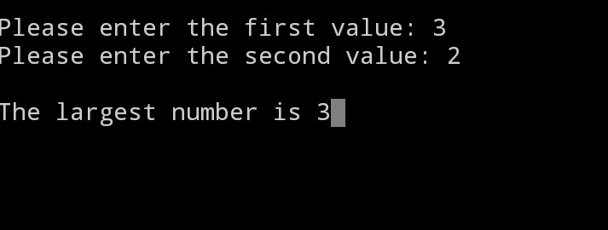

2. #include <iostream>  
using namespace std;  
  
int main()  
{  
 unsigned int n;  
 unsigned long long factorial = 1;  
  
 cout << "Enter a positive integer: ";  
 cin >> n;  
  
 for(int i = 1; i <=n; ++i)  
 {  
 factorial \*= i;  
 }  
  
 cout << "Factorial of " << n << " = " << factorial;   
 return 0;  
}

